**ITERATION-1**

We are working on an issue posted by contributors of the truffle package. This involves reproducing the issue, finding the cause of the issue, and fixing it.

In this iteration, we worked on finding the modules required to be fixed and install the tools and packages required in fixing the issue.

Issue : **Bug: @truffle/require not able to resolve locally-installed modules (e.g. ts-node, typescript) when running under the globally-installed truffle bundle** [**#5381**](https://github.com/trufflesuite/truffle/issues/5381).

## **Frameworks:**

**Truffle** - It is an open-source development framework that allows users to develop, test and asset pipeline for ethereum.

**Ganache** - It is an ethereum simulator that makes developing ethereum applications faster and easier.

**Lerna** - It is a framework for managing and publishing multiple JS/TS packages from a single repo which is used by truffle for its packages.

## **Package Manager:**

**npm** - It is the default package manager for javascript runtime environment Node.js.

## **Installing Node & NPM:**

Reference: <https://docs.npmjs.com/downloading-and-installing-node-js-and-npm>

## **Installing Truffle:**

This iteration is in fixing an issue that lies on the truffle version @5.5.24. We are going to install **truffle@5.5.24**

To install truffle@5.5.24, run the below command to install truffle: [1]

$ npm install -g truffle

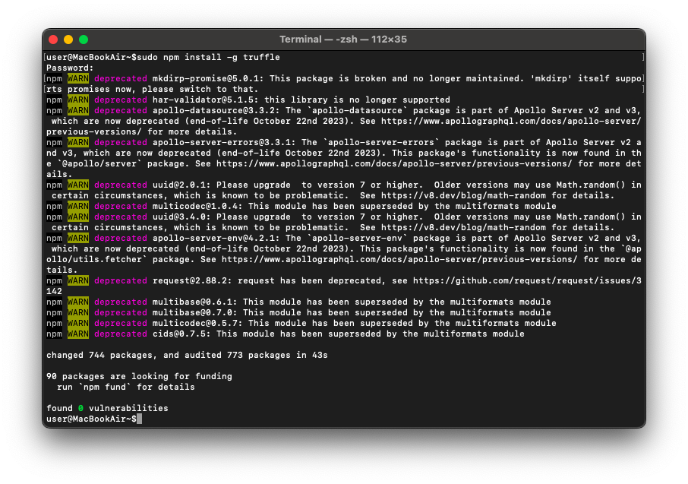

## **Installing Ganache:**

To install ganache, run the below command: [2]

$ npm install -g ganache

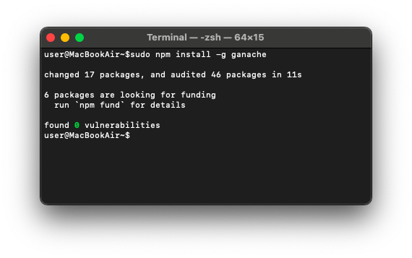

## **Reproducing The Issue:**

I have reproduced the issue by following the steps as mentioned in the issue.

Steps to reproduce,

* With the truffle installed, unbox any templates. we unboxed Metacoin by running: [3]

$ truffle unbox MetaCoin MetaCoin

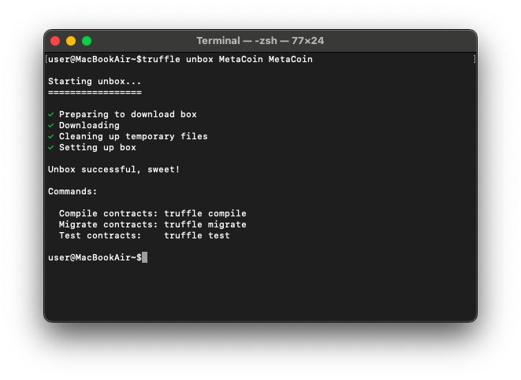

* Change the working directory to MetaCoin and run the below commands to add typescript modules: [4]

$ npm i -D typescript

$ npm i -D ts-node

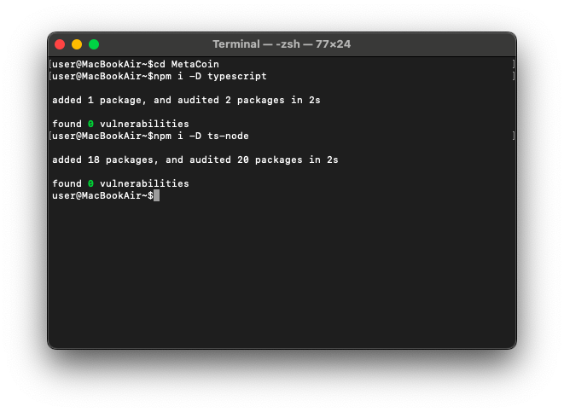

* Configure truffle-config.js to connect to my local node by running the below command in a separate terminal: [5]

$ ganache

* Rename 1_deploy_contracts.js to 1_deploy_contracts.ts and run:

$ truffle migrate --reset

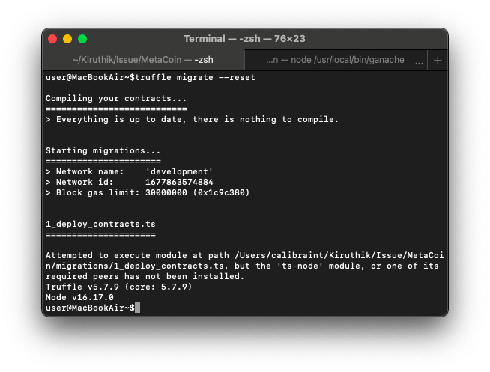

From the above REFERENCE [5], we have reproduced the issue.

## **Finding The Issue:**

@truffle/require is responsible for importing modules and its supported typescript in default but fails to do so when the project couldn’t check for its (ts-node) peer dependencies.

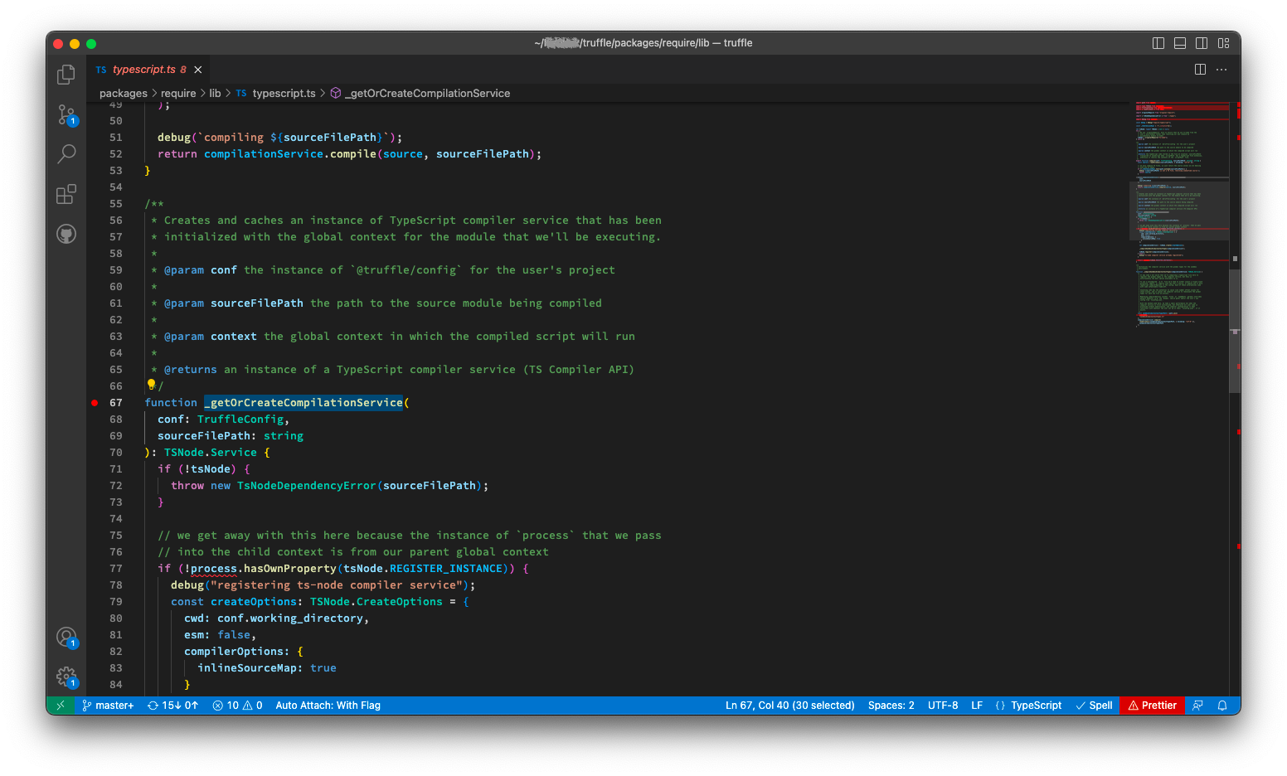

## **Work Plan for Remaining Iterations:**

Iteration 1: Reproduce the issue, explore the packages, and find the issue.

Iteration 2: Bootstrap truffle source code and integrate ts-node locally.

Iteration 3: Add a flag to unbox typescript added boxes.

## References:

* <https://github.com/trufflesuite/truffle#install> [1]
* <https://github.com/trufflesuite/ganache#command-line-use> [2]
* <https://github.com/trufflesuite/truffle/issues/5381> [3], [4] and [5]

Team 1:

SAICHARAN PAGIDIMUNTHALA – 1002006773

RAMYA MADDINENI - 1001965818

BHARGAV SUNKARI - 1002028016

DILEEP KUMAR NAIDU RAVI - 1002023397